REGN NO: FA25-BCS-030 |  | NAME:HASNAT GUL
COURSE: DATA STRUCTURE LAB  SINGLY LINKED LISTS  TASK 01:  #include <iostream> using namespace std;  // Node structure struct Node  { int data;  Node* next;  };  // Insert node at end void insertEnd(Node*& head, int value)  {  Node* newNode = new Node;  newNode->data = value; newNode->next = NULL;  if (head == NULL)  {  head = newNode;  return;  }  Node* temp = head; |  | LAB TASK
while (temp->next != NULL)
{
temp = temp->next;
}

temp->next = newNode;
}

// Display Linked List void display(Node* head)
{
Node* temp = head;

while (temp != NULL)
{
cout << temp->data << " "; temp = temp->next;
}

cout << endl;
}

// Reverse using Loop void reverseUsingLoop(Node* head)
{ int arr[100]; int count = 0; Node* temp = head;

while (temp != NULL)
{
arr[count] = temp->data; count++;

temp = temp->next;
}

cout << "Reverse using Loop: ";

for (int i = count - 1; i >= 0; i--)
{ cout << arr[i] << " ";
}

cout << endl;
}
// Reverse using Recursion void reverseUsingRecursion(Node* head)
{ if (head == NULL)
{ return;
}

reverseUsingRecursion(head->next); cout << head->data << " ";
} int main()
{
Node* head = NULL;

// Create Linked List insertEnd(head, 10); insertEnd(head, 20); insertEnd(head, 30); insertEnd(head, 40); insertEnd(head, 50);

// Original List cout << "Original Linked List: "; display(head);

// Reverse using Loop reverseUsingLoop(head);

// Reverse using Recursion cout << "Reverse using Recursion: "; reverseUsingRecursion(head); cout << endl;

return 0; }
OUTPUT:
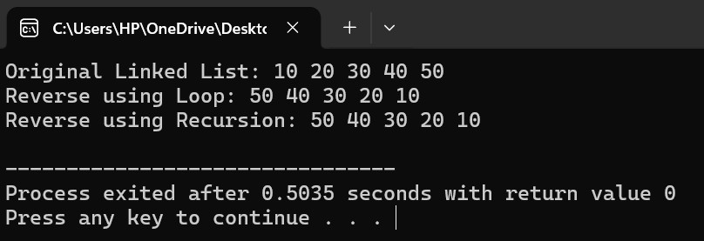
TASK 02:
#include using namespace std;
// Node structure struct Node { int data; Node* next; };
// Insert node at end void insertEnd(Node*& head, int value) { Node* newNode = new Node;
newNode->data = value; newNode->next = NULL;

if (head == NULL)
{
head = newNode; return;
}

Node* temp = head;

while (temp->next != NULL)
{
temp = temp->next;
}

temp->next = newNode;

}
// Display Linked List void display(Node* head) { Node* temp = head;
while (temp != NULL)
{
cout << temp->data << " "; temp = temp->next;
}

cout << endl;

}
Node* mergeLists(Node* head1, Node* head2) { Node* head3 = NULL;
// Copy first list into third list
Node* temp = head1;

while (temp != NULL)
{
insertEnd(head3, temp->data); temp = temp->next;
}

// Copy second list into third list temp = head2;

while (temp != NULL)
{
insertEnd(head3, temp->data); temp = temp->next;
}

return head3;

} int main() { // First Linked List Node* list1 = NULL;
insertEnd(list1, 10); insertEnd(list1, 20); insertEnd(list1, 30);

// Second Linked List
Node* list2 = NULL;

insertEnd(list2, 40); insertEnd(list2, 50); insertEnd(list2, 60);

// Display first list cout << "List 1: "; display(list1);

// Display second list cout << "List 2: "; display(list2);

// Merge into third list
Node* list3 = mergeLists(list1, list2);

// Display third list cout << "Merged List (List 3): "; display(list3);

return 0;

}
OUTPUT:
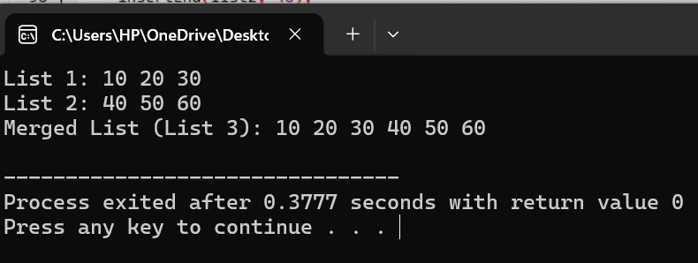
TASK 3:
#include <iostream> using namespace std; // Node structure struct Node { int data;
Node* next;
};

// Insert node at end void insertEnd(Node*& head, int value)
{
Node* newNode = new Node;

newNode->data = value; newNode->next = NULL;

if (head == NULL)
{
head = newNode;
return;
}

Node* temp = head;

while (temp->next != NULL)
{
temp = temp->next;
}

temp->next = newNode;
}

// Display Linked List void display(Node* head)
{
Node* temp = head;

while (temp != NULL)
{
cout << temp->data << " "; temp = temp->next;
}

cout << endl;
}

void findOccurrences(Node* head, int value)
{
Node* temp = head; int position = 1; int count = 0;

cout << "Occurrences of " << value << " found at positions: ";

while (temp != NULL)
{
if (temp->data == value)
{
cout << position << " "; count++;
}

temp = temp->next; position++;
}

if (count == 0)
{
cout << "No occurrence found.";
}

cout << endl;

cout << "Total occurrences = " << count << endl;
}

int main()
{
Node* head = NULL;

// Create Linked List insertEnd(head, 10); insertEnd(head, 20); insertEnd(head, 30); insertEnd(head, 20); insertEnd(head, 40); insertEnd(head, 20); // Display list cout << "Linked List: "; display(head);

// Find occurrences of 20 findOccurrences(head, 20);

return 0;
}
OUTPUT:
